TOWNSHIP OF
MECæTA COUNTY, MICHIGAN
ORDINANCE NO. 26- 01
AN ORDNANCE ABOLISHING THE TAX INCREMENT FINANCING PLAN AND ENDING THE TAX CAPTURE OF THE m-1EATLAND TOWNSHIP (REMUS AREA) DOWNTOVVN DEVELOPMENT AUTHORITY.
WHEREAS, Wheatland Toymship approved and enacted the Tax Increment

Financing (TIF) Plan, attached as EXHIBIT A, to fund the  Towrship Downtown Development Authority (DDA), and
WHEREAS, ad valorem property tax revenue has been "captured" since adoption of the TIF Plan to fund projects identified by the DDA Development Plan, and
WHEREAS, MCL 125.4215(2) authorizes the mLeat1and Township Board to abolish the TIF and end the ad valorem property tax "capture" for DDA activities when the purposes for which it was established are accomplished, and

IN}-IEREAS, the Wheatland Township Board finds that the purposes for which the TIF was established are accomplished, and desires to abolish and terminate the TIF
Plan and tax capture without dissolving the DDA,
NOW, THE TOWNSHIP OF WHEATLAND ORDAINS:
Section 1. Abolition of Tax Increment Financing ("TIF") Plan.
l. The purposes for which the current tax increment financing plan (TIF) of the INheatland Township Downtown Development Authority (DDA) have been accomplished.
- Pursuant to MCL 125.4215(2) the TIF is hereby abolished, effective inunediately, and ad valorem property tax revenue increments shall not be captured or bansferred to the DDA by the Wheatland Township Treasurer and/or Mecosta County Treasurer.
- No provision of this Ordinance shall be construed as dissolving the DDA.
Section 2. Severability and Conflicting Ordinances.
1
l. If any provision of this Ordinance shall be held invalid or unconstitutional by any court of competent jurisdiction, the remaining provisions of this Ordinance shall remain valid and enforceable.
2. All ordinances or ordinance provisions inconsistent with this Ordinance are hereby repealed to the extent of such inconsistency. Provided, however, that the ordinance or ordinance provision shall be repealed only to the extent of such inconsistency, and shall remain in all other respects valid and enforceable.
Section 3. Effective Date, Publication and Mailing, Inspection.
- The Township Clerk shall promptly publish a copy of this Ordinance in a newspaper of general circulation within the Township, and send copies of this Ordinance to the Secretary of State and to all property bcpayers of record in the downtown distict and the governing body of each taxing jurisdicäon levying taxes that would be subject to capture. This Ordinance shall uke effect the day following publication of the Ordinance in the newspaper pursuant to MCL 41.184(2).
- A copy of this Ordinance can be inspected and obtained from the Township aerk at the Wheatland Township offices at 201 S Sheridan Ave, Remus,
49340.
YEAS:
NAYS:
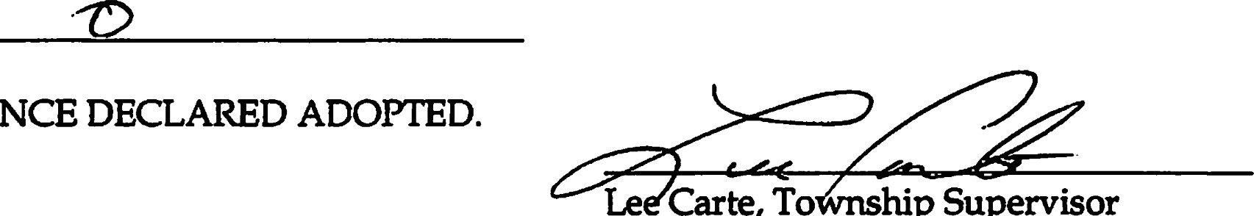ABSENT:
ORDINANCE
Le
Carte,
To
hip
Supervisor
CERTIFICATION
I, Kirn Thiel, the duly elected Clerk of the Township of Wheatland, hereby certify as follows:
l. The above is a frue copy of an Ordinance adopted by the Wheatland Township
Board at a duly scheduled and noticed meeting of that Tovvnship Board held on 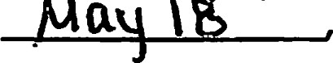2026, pursuant to the required statutory procedures.
- A sununary of the above Ordinance was duly published in the
P imeer newspaper, a newspaper that circulates within Wheatland Township, on May 0-1 , 2026.
- Within one week after the publication, I recorded the above Ordinance in a book of ordinances kept by me for that purpose, including the date the Ordinance was adopted, the names of the members of the Township Board voting, and how each member voted.
ATTESTED:
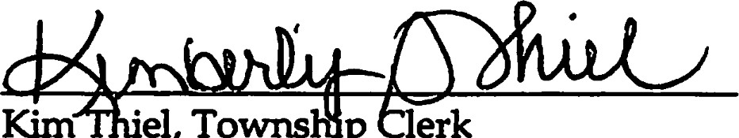
Kim
'el,
Towms
p
3

